# File permissions in Linux

## Project description

[Describe what you accomplish through Linux commands.]

Before i dont know the commands but because of coursera i’ve got my hands on linux and make me do commands with them i’ve learn pwd, cd, ls, grep, ls, Piping, chmod, DRWXRWXRWX and more.

## Check file and directory details

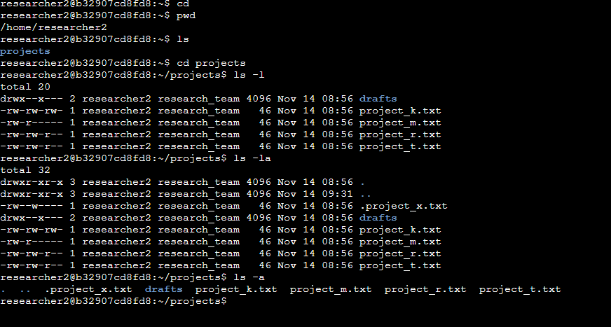

## Describe the permissions string

Read to read the files, Write to change something in file, Execute to make a change in directory

## Change file permissions

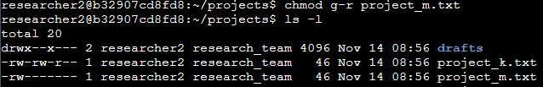

## Change file permissions on a hidden file

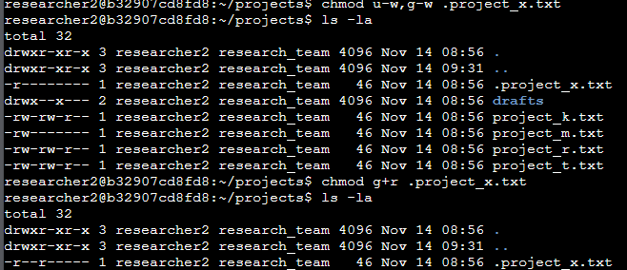

## Change directory permissions

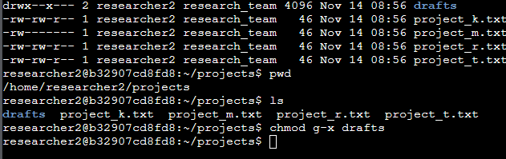

## Summary

[Add content here.]

With the help of guidelines and coursera i'm getting used to commands of linux